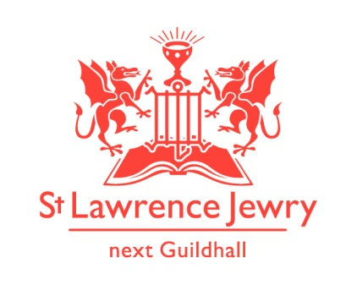
St Lawrence Jewry January 2019 Newsletter
St Lawrence Jewry is the church on Guildhall Yard, dedicated to bringing
the light of Christ to the City of London.

Dear Friends,

“Therefore, if anyone is in Christ, the new creation has come: The old has gone, the new is here!”
(2 Corinthians 5:17 NIV)

A blessed and happy New Year to everyone! We hope you had a festive Christmas break. Apologies for sending a late January newsletter due to staff holiday. The church has been open since Wednesday 2nd January.

Services each week

Our weekly services continue as usual. Holy Communion at 8.30am on Wednesday and 1.15pm on Friday.

Music

Our piano and organ recitals started again this year on 7^{h} and 8th January, respectively. For details of the artists and their programmes, please visit our webpages Piano or Organ.

Fabric

The plans for the church restoration project are now actively going forward. At the end of last year and the beginning of this year we have some temporary holding works going ahead. This is an attempt to stem the water coming into the church. Assuming all goes well we should have some buckets for sale in the near future. The main project will probably go ahead from May 2020 for 18 months. There is a lot to be done. Watch this space for more news.

We have also placed an order for the glass doors in December. We are still waiting for their delivery date. We’ll update you on this in our next newsletter. Watch this space.

Christmas Big Give Challenge 2018

Many thanks to all the people who contributed to the Christmas Big Give Challenge 2018. This was a great success and we raised a total of £3,262. This is connected with the above project. We hope to add into the restoration project a refurbishment of the clock faces and the money raised from the Christmas Tree project will be set aside towards the cost of that.

‘Have You Seen My Childhood?’ Exhibition

We are privileged to host the first solo exhibition of Iranian artist, Khatereh Shoja. The focus of her exhibition is on the traumatic experiences suffered by children present in a war or major international conflict. The exhibition will run from Monday 7th to Thursday 10th January 2019 only. A special private viewing is scheduled on Tuesday 8th January at 6pm. All art work is on sale through public bidding and proceeds will go to the church and the Charity Art in Homes.

Plow Monday Service

We kicked off the year with the Plow Monday Service on 7th January 2019, attended by our Lord Mayor and the Lady Mayoress. This year’s focus was on the City of London Corporation Community and Children Services Department. Whilst the purpose is to pray for ALL staff, we usually focus on one department and this year our Lord mayor has an interest in Children and Young people, so he chose this department.

Baptisms

We are starting this year with 3 baptisms:

Erin Wirz on Friday 18th January during our Holy Communion Service at 1:15pm
Hunter Easdon and his dad, Lee, on Saturday 19th January at 11am.

Please include them in your prayers and as they start their lives as Christians.

Advance Notice

7th February 6:30 pm - Waitangi Day Service
12th February 5:30pm - Sheriffs Pen Presentation
4th March 6:30pm - CoL Benefices Evensong
5th March 6:30 pm - City of London Guides Melluish Lecture
7th March 12 noon - Spital Sermon

God bless you all.

David Parrott
vicar@stlawrencejewry.org.uk

If you receive this newsletter but would not wish to stay on our list please let us know straight away and we will remove you.

Katrina Bradley
katrina@stlawrencejewry.org.uk

Arnel Sullano
arnel@stlawrencejewry.org.uk

