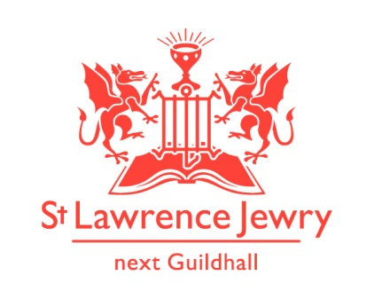
St Lawrence Jewry
December 2018 Newsletter
St Lawrence Jewry is the church on Guildhall Yard, dedicated to bringing
the light of Christ to the City of London.

Dear Friends,

“For God so loved the world that he gave his one and only Son, that whoever believes in him shall not perish but have eternal life.” John 3:16

Christmas season is here and you can feel the hustle and bustle everywhere, not only in shops but also in St Lawrence Jewry.

But the spirit of Christmas is not about us being busy with carol services, or shopping, or sending Christmas cards to people. It is the spirit of love, of giving, of believing. We as Christians, celebrate Jesus’ birth at Christmas, the day we receive the greatest gift of all, our dear Saviour, Jesus Christ. This Christmas season, let us remember the other gifts God is continuously giving us through St Lawrence Jewry.

Gift No. 1 – Carol Services

Our church will be filled with carols again with 22 carol and music events in the next few weeks. All services are open to the public (although where an organisation is doing refreshments afterwards these are not usually open to all comers), but the two we particularly invite you to amongst these carol services are:

City of London Corporation Staff and City Police Carol Service Wednesday 5th December 1:00pm

The Lord Mayor’s Carol Service Wednesday 19th December 5:30pm.

Refreshments will follow after these services. Everyone is invited.

Gift No. 2 – Music

Our music programme continues in December as ever. For programmes of our Piano and Organ recitals, please visit our website. Other dates to remember:

18th December 1pm - SLJ Organ and Choir with Reading Carol Concert – free

In our own series the last piano concert of the year is on Monday 17th December and the last Organ concert is on 18th December when our wonderful choir and organist will lead us in carols and readings for Christmas.

Piano concerts resume on Monday 7th January and organ concerts on Tuesday 8th January.

Gift No. 3 – Celebration of Marriage

Despite our reluctance to accept other services because of the numerous Carol Services we have this month, we can’t stop the spirit of love in this church. We have three celebration of marriages:

Dec 1st at 3:00pm - Max Trowbridge and Stephanie Leonard
Dec 21st at 3:30pm – Charlie Tighe and Gillan Wilson
Dec 22nd at 4:00pm – Charles Steward and Harriet Levett

Let’s all include them in our prayers as they start their married lives together.

Gift No. 4 - Restore, Décor and Remember Big Give Challenge

As you all know, St Lawrence Jewry has joined the Big Give Christmas Challenge 2018. We joined this campaign so that we can raise fund to restore our clock faces. We would like to thank all of you who have shown their support to this fundraising event we called. You can donate any amount and we will remember any person you nominate during our services in the month of December. But for every £25 donation, we can create for you a personalised Christmas décor with the name of your nominated person. We will display this personalised decor on our Christmas Tree this year. You can claim and keep this décor as a memento after the Lord Mayor’s Carol Service on Wednesday 19th December at 5:30pm where you are also invited to attend.

There is a chance to double your donation by doing it online through the Big Give Christmas Challenge 2018 website from today until to midday Tuesday 4th December. You will need to type in “St Lawrence Jewry” as the participating charity. Please watch this video clip to know more about this nationwide campaign.

So far, we have received 36 Christmas decor requests and £1,195 in donations. We need more than that to fill our 11-foot Christmas Tree this year. So we encourage you to send in your orders now by completing the attached form and sending it back to Arnel via email or post.

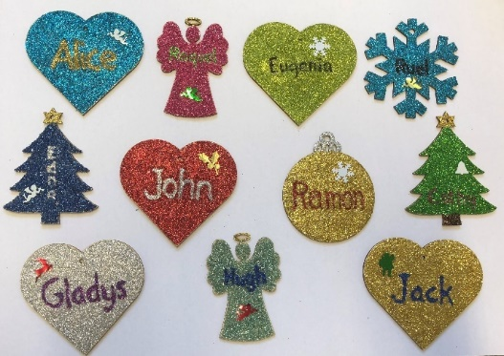

Gift No. 5 - Other fundraising activities

So far, we have raised £755.53 with 24 supporters with Easyfundraising. Please join easyfundraising at https://www.easyfundraising.org.uk/causes/stlawrencejewry/ and you can collect free donations for us every time you buy something online. It won’t cost you a penny extra so please help us to raise funds this way.

Help us WIN! #easyfundraising are giving away £10,000 in prizes in their Advent Calendar Giveaway!! There are daily prizes of £250 and a Christmas Day Grand Prize of £5,000 for one cause. It’s starts on Saturday, so let’s get as many entries as we can and see if St Lawrence Jewry Church - London can win! Please share, tag, retweet as much as you can - it’s totally free, to find out more, visit:
https://www.easyfundraising.org.uk/advent-calendar-coming-soon

Please don’t forget that we also collect used stamps to raise fund for our church. Please drop them off to the church office and we will do the rest.

Gift No. 6 - Giving online / Donation by card

We also have an online giving facility in our website through Stewardship Give.Net. By just click the Support Us button in our homepage, you can now donate online by using either your debit or credit card.

We also now accept donation/payment by card in the church with our card reader. Please spread this good news!

Gift No. 7 - Fabric Matters - Raise the Roof – The Big Project

We are near to installing our new glass doors. It might happen in February 2019. Watch this space.

We have also been very pleased to hear from the City of London Corporation that they are able to support the major restoration to the church fabric, so badly needed. We thank those who have worked so hard to get to this stage. The very first stage is to stem the flow of water through the church roof. This should happen very soon, hopefully in December. If anyone would like to buy a bucket we shall have lots spare soon!

The big project is projected to take place from mid 2020 to mid 2021. Please pray that this comes to fruition.

More Gifts to come

Plow Monday Service – 7th January 2019 at 5:30pm. Lord Mayor and Lady Mayoress are in attendance. This is the service in which we pray for the staff and work of the City of London Corporation at the beginning of another year.

Church Opening Times

The church will be closed from 23rd December 2018 until 1st January 2019. We will open our door again starting Wednesday 2nd January 2019. Holy Communion Service will resume on that day.

As one year is about to end, we give our heartfelt gratitude to everyone who have been involved, in one way or another, with St Lawrence Jewry this year. It has been a very busy year for us that brought lots of joy in our hearts. To all the livery companies down to the single individual who have given their supports to us, words are not enough to thank you all.

We wish you all a very happy Christmas and a blessed new year to come.

God bless you all.

David Parrott
vicar@stlawrencejewry.org.uk

If you receive this newsletter but would not wish to stay on our list, please let us know straight away and we will remove you.

Katrina Bradley
katrina@stlawrencejewry.org.uk

Arnel Sullano
arnel@stlawrencejewry.org.uk

We’ve updated our Privacy Policy which can be found at http://stlawrencejewry.org.uk/privacy-notice/ . If you have any questions or would like a printed copy, then please let us know.

