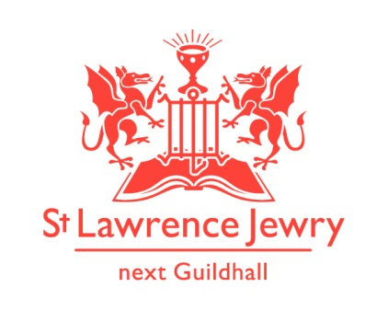
St Lawrence Jewry November 2018 Newsletter
St Lawrence Jewry is the church on Guildhall Yard, dedicated to bringing
the light of Christ to the City of London.

Dear Friends,

“I thank my God every time I remember you. ⁴ In all my prayers for all of you, I always pray with joy.” (Philippians 1:3-4 NIV)

November is a month of Remembrance and Thanksgiving. Who do you remember and pray for during this month?

In the church we are thankful for the following blessings:

Blessing 1: Services each week

Our Holy Communion services continue every Wednesday at 8:30am and Friday at 1:15pm. We are grateful for the increase of people attending to these services. We are also thankful to the increase of visitors who come regularly to pray in the church.

Blessing 2: Special Services

Aside from the Civic Services of the Lord Mayor and the Livery Companies, we are honoured to host other services too. The Airborne Forces will have their 73rd Annual Memorial Service on Friday 9th November at 11:30am. We are honoured to host also the first ever Guild of Entrepreneurs Installation Service on Wednesday 28th November at 5:30pm.

Blessing 3: Weddings

We are blessed to have 18 Celebrations of Marriage this year. Hollie Walton & David Yallop will celebrate theirs on Saturday 3rd November at 2pm. Please include them as they start their married lives on that day.

Blessing 4: Memorial Services

We are thankful for 8 Celebration of Life this year. For November we are celebrating the lives of David James (Past Master Girdler) on Wednesday 7th November at 2:30pm and Richard Sermon (Past Sheriff) on Wednesday 21st November at 11.00am. Please include their families and friends in your prayers.

Blessing 5: Music

We congratulate The Eric Thompson Trust for their silver anniversary and a successful organ concert series this year. This November, our Director of Music and resident organist, Catherine Ennis, will perform in most of the organ recital, except for the 27th November where we will have the pleasure of hearing Sebastian Heindl from Germany to perform. To see their programmes, please visit our Organ webpage.

For our Piano recitals we have Kanae Furomoto on Monday 5th, Kevin Ayesh on Monday 12th, Marina Koka on Monday 19th, and Simone Tavoni on Monday 26th November. For their programmes, please visit our Piano webpage.

We welcome back the City of London Boys School for their annual lunchtime concert in the church on Thursday 15th November at 1:00pm.

On Sunday 18th November, we will have two concerts in the church. There is a “Night of Broken Glass” concert at 12pm to commemorate Kristallnacht. It is a free event but donation is invited and all are welcome. This event is being organised by Beth Rankin of the Australia Catholic University in Melbourne Australia and involves two way live streaming! David stayed with Beth when he was on sabbatical in Australia. More details are on our Concert webpage .

Then at 6pm, the Barts Chamber Choir will perform their “O for the Wings of a Dove” Concert, with Hilary Campbell as the Conductor, Benedict Lewis-Smith, the organist, and Gwen Martin as the Soprano Soloist. Ticket is at £15 (unallocated seating), available online www.bartschoir.com or at the door.

Blessing 6: Bells

The bells at St Lawrence are said to be some of the best in the whole of London. They are rung for the Lord Mayor’s Show and for other major events. (see Blessing x below). This weekend ringers from across the country visit London for the annual ringing by the Ancient Society of College Youths. In the evening they hold a grand Ball at a London hotel. The clergy of the towers where they ring are invited. Another dinner for David! ( http://ascy.org.uk/ )

Blessing 7: Lord Mayor’s Show

We encourage everyone to join us in this year’s 803th Lord Mayor’s Show on Saturday 10th November. Although officially the start is at 11am from Mansion House the Lord Mayor, Hon Alderman Peter Estlin, will leave Guildhall on the Golden Coach at exactly 10:42am to the sound of St Lawrence Jewry’s full bell peal. Look out for David on the Mansion House balcony, as the parade passes by. For more details of the event, please visit The Lord Mayor’s Show website.

The BBC is doing a documentary about the Show preparations which will include shots from the church roof! Watch out for this.

Blessing 8: Interfaith

David is Chaplain to the City of London Corporation. Each year we host a service to remember those who have died. This is an interfaith event for all in Guildhall who would wish to attend. It takes place this year on 14th November at 12.15pm. This represents the opportunities we have here to minister to people of many faiths and none.

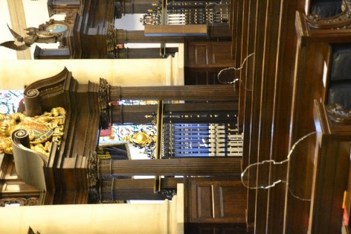
Blessing 9: There but not there

This event (http://therebutnotthere.org.uk ) is a national remembrance of those who dies unknown in WW1. We have a set of the transparent silhouette figures on display in the church for the weeks either side of remembrance. Do come and take a look if you are nearby. Katrina has created a “There But Not There” leaflet for people to take away.

Blessing 10: Carol Services

Oh my! That is just November. Then we hit the busy month of December – more on that in the next newsletter. As you can see we have so many amazing ministry opportunities here in the City. Please do pray for David and the team as we seek to take every chance we can to ‘Bring the Light of Christ to the city of London’.

Blessing 11: Fundraising Activities

- Diamond Anniversary Appeal
We would like to thank everyone who supported us in our Diamond Anniversary Appeal. We raised £20,800 for our new glass doors. We will update when they will be installed once we have the date finalised. Raising the money was easier than the technicalities of getting the doors installed, but we are working on it.

- Restore, Décor & Remember
We would like to thank all those people who have shown their support to this fundraising campaign. We hope to raise fund to Restore the clock faces on our tower by helping us Decorate our Christmas tree with personalised Christmas décor to Remember someone you love. How does it work?

- We want you to donate £25 per personalised Christmas Décor which will bear the name of the person you wish to be remembered for the month of December. This may be someone who has died, or your husband or wife or child, or any other name you would like to be remembered in this way.

- The Christmas décor will be used to decorate our Christmas tree this year.

- All who have donated will be invited to attend the Lord Mayor’s Carol Service on Wednesday 19th December at 5:30pm. They can collect their personalised Christmas décor after the service, or any time thereafter, as a memento.

You may donate your £25 or any amount at any time, but…

There is a chance to double your donation if you will donate online through The Big Give Christmas Challenge website between Tuesday 27th November and Tuesday 4th December. We would like to thank The Friends of the City Churches who pledged £1,250 to match fund any donation we raise during that week. Watch this space for further details about this scheme. If you would like to register your interest in the scheme then please complete the form which is available in the church or online to download. We would appreciate if you can complete the form as soon as possible to give ample time for Arnel to make the personalised decors.

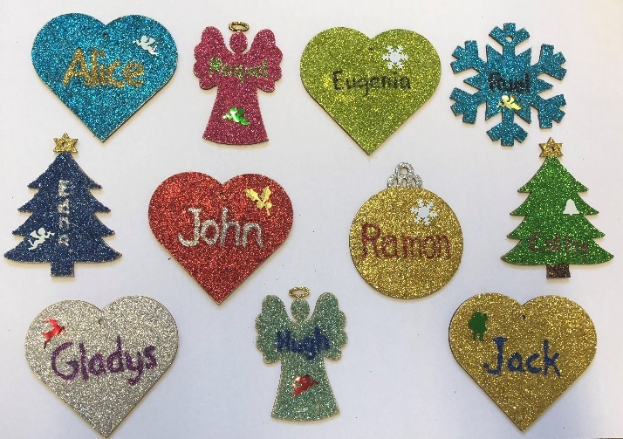

C. Online Shopping
All abroad for big donations. Collect FREE donation for St Lawrence Jewry when you book your holiday or purchase anything online through easyfundraising. Earn a 50p bonus donation for the church every time someone successfully joins and raises as a supporter through this unique link https://www.easyfundraising.org.uk/invite/1ZIJMC/49ZRGU/. Once you’re registered you can choose from among +3,200 retailers that you want to shop. Every time you check out, the retailer(s) will donate certain percentage of your total payment to St Lawrence Jewry.

For Amazon shoppers, you can shop through the Amazon Smile with this link https://smile.amazon.co.uk/ then choose St Lawrence Jewry Guild Church Council as the charity you want to support. Amazon donates 0.5% of the net purchase price (excluding VAT, returns and shipping fees) of eligible purchases to the church.

D. Used Stamps
Please don’t forget that we also collect used stamps to raise fund for our church. Please drop them off to the church office and we will do the rest.

Advance Notices

Wednesday 5th December at 1pm – CoL Staff & Police Carol Service
Tuesday 18th December at 1pm – Seasonal Readings and Carols
Wednesday 19th December at 5:30pm - Lord Mayor’s Carol Service

God bless you all.

David Parrott
vicar@stlawrencejewry.org.uk

If you receive this newsletter but would not wish to stay on our list, please let us know straight away and we will remove you.

Katrina Bradley
katrina@stlawrencejewry.org.uk

Arnel Sullano
arnel@stlawrencejewry.org.uk

We’ve updated our Privacy Policy which can be found at http://stlawrencejewry.org.uk/privacy-notice/ . If you have any questions or would like a printed copy, then please let us know.

