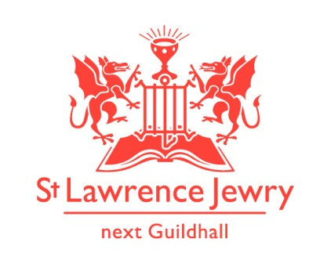
St Lawrence Jewry October 2018 Newsletter
St Lawrence Jewry is the church on Guildhall Yard, dedicated to bringing
the light of Christ to the City of London.

Dear Friends,

“I tell you, use worldly wealth to gain friends for yourselves, so that when it is gone, you will be welcomed into eternal dwellings.” (Luke 16:9 NIV)

How do we use our worldly wealth? Are we gaining friends or the opposite?

Services each week

Our Holy Communion services continue every Wednesday at 8:30am and Friday at 1:15pm. All are welcome.

Special Services

Although the summer is now gone, our church is still feeling the heat this month with many special services. We kick off with the Lord Mayor’s Election Day Service on Monday 1st October at 10:45am. This is the most pompous annual service happening in this church. The Guild of Nurses will also have their Annual Service on Tuesday 9th October at 6pm. We also have two Livery Installation Services: the Constructors and Insurers on Wednesday 10th and Thursday 25th, respectively, both at 5:30pm. The City of London Pensioners Association will also have their Annual Service on Friday 19th at 11am.

Wedding / Memorial Services

There are three Celebrations of Marriage this month:

Saturday 6th October at 2pm - Ami Hallford & Jack Chavner
Saturday 13th October at 2pm - Lauren Newman & James Lowley
Saturday 27th October at 2pm – Sarah Rutherford & Stephen Moi

There are also three Celebration of Life for the following people:

Thursday 11th October at 3pm – Simon Harris
Tuesday 16th October at 2:45pm – Patrick Dunn
Wednesday 31st October at 1pm – Chris Haydon

Please include them and their families and friends in your prayers.

Music

We congratulate The Eric Thompson Trust for their silver anniversary this year. To commemorate this special year, The Eric Thompson Organ Series this October kicks off with Ourania Gassiou on Tuesday 2nd October, followed by Joseph Fort on Tuesday 9th, then by Hannah Parry on Tuesday 16th and closed by Stephen Disley on Tuesday 23rd. For their full programmes, please click The Eric Thompson Trust Organ Series 2018.

On Tuesday 30th October, we depart from normal lunchtime organ series. Instead, we are screening a classic silent film, “The Red Balloon” (Albert Lamorisse, 1958) while Swedish organist Stefan Therstam will improvise organ accompaniment. Admission is free but donation invited.

For our Piano recitals we have Hiroaki Takenouchi on Monday 1st, Ryan Drucker on Monday 8th, Phillip Leslie on Monday 15th, the Zarebski Piano Duo on Monday 22nd and Michael Lan on Monday 29th October. For their programmes, please visit our Piano webpage.

Fundraising Activities

We started a new fundraising campaign entitled “Restore, Decor & Remember”. We hope to raise fund to Restore the clock faces on our tower by helping us Decorate our Christmas tree with personalised Christmas décor to Remember someone you love. How does it work?

- We want you to donate £25 per personalised Christmas Décor which will bear the name of the person you wish to be remembered for the month of December. This may be someone who has died, or your husband or wife or child, or any other name you would like to be remembered in this way.

- The Christmas décor will be used to decorate our Christmas tree this year.

- All who have donated will be invited to attend the Lord Mayor’s Carol Service on Wednesday 19th December at 5:30pm. They can collect their personalised Christmas décor after the service, or any time thereafter, as a memento.

You may donate your £25 or any amount at any time, but…

There is a chance to double your donation if you will donate online through The Big Give Christmas Challenge website between Tuesday 27th November and Tuesday 4th December. We would like to thank The Friends of the City Churches who pledged £1,250 to match fund any donation we raise during that week. Watch this space for further details about this scheme. If you would like to register your interest in the scheme then please complete the form which is available in the church or online to download. We would appreciate if you can complete the form as soon as possible to give ample time for Arnel to make the personalised decors.

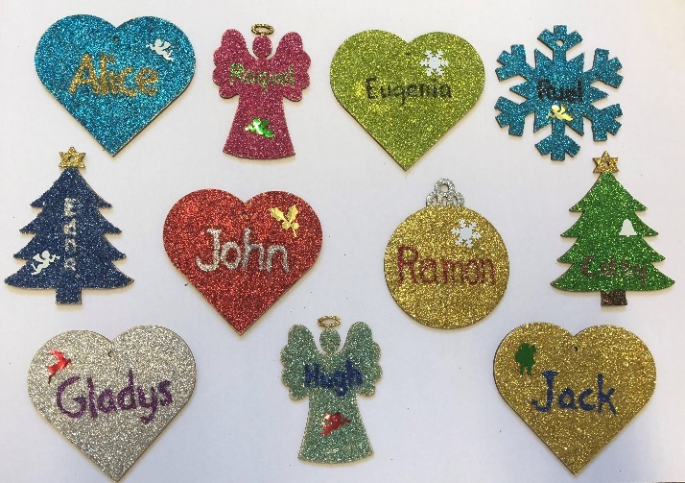

Online shopping fundraising

All abroad for big donations. Collect FREE donation for St Lawrence Jewry when you book your holiday or purchase anything online through easyfundraising. Earn a 50p bonus donation for the church every time someone successfully joins and raises as a supporter through this unique link https://www.easyfundraising.org.uk/invite/1ZIJMC/49ZRGU/. Once you’re registered you can choose from among +3,200 retailers that you want to shop. Every time you check out, the retailer(s) will donate certain percentage of your total payment to St Lawrence Jewry.

For Amazon shoppers, you can shop through the Amazon Smile with this link https://smile.amazon.co.uk/ then choose St Lawrence Jewry Guild Church Council as the charity you want to support. Amazon donates 0.5% of the net purchase price (excluding VAT, returns and shipping fees) of eligible purchases to the church.

Please don’t forget that we also collect used stamps to raise fund for our church. Please drop them off to the church office and we will do the rest.

Advance Notices

Saturday 10th November – Lord Mayor’s Show
Thursday 15th November at 1pm – City of London Boys School String Orchestra Concert – Free admission
Sunday 18th November at 6pm - Barts Chamber Choir Concert – visit their website for ticket/info

God bless you all.

David Parrott
vicar@stlawrencejewry.org.uk

If you receive this newsletter but would not wish to stay on our list, please let us know straight away and we will remove you.

Katrina Bradley
katrina@stlawrencejewry.org.uk

Arnel Sullano
arnel@stlawrencejewry.org.uk

We’ve updated our Privacy Policy which can be found at http://stlawrencejewry.org.uk/privacy-notice/ . If you have any questions or would like a printed copy, then please let us know.

