The Christopher Wren Window
by Christopher Webb
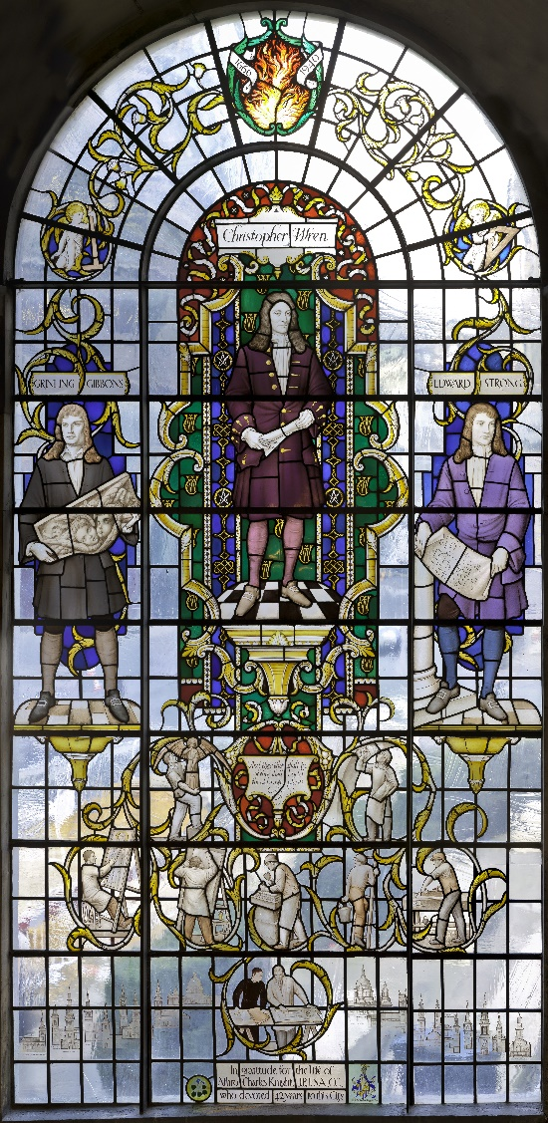
For a more detailed explanation of the items and people in this beautiful window please go to –
https://artsandculture.google.com/story/YQIiG8cmbFw8JQ

