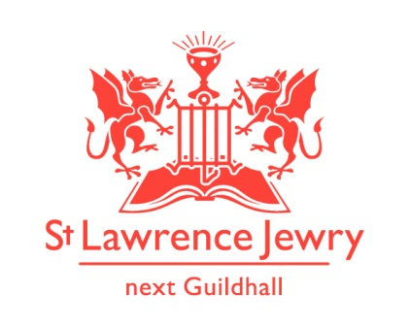
St Lawrence Jewry April 2018 Newsletter
St Lawrence Jewry is the church on Guildhall Yard, dedicated to bringing
the light of Christ to the City of London.

Dear Friends,

“Jesus came and stood among them and said, Peace be with you!’ After he said this, he showed them his hands and side. The disciples were overjoyed when they saw the Lord.” (John 20: 19-20 NIV)

Halleluiah! Christ is Risen! Halleluiah! As we celebrate Easter, are we overjoyed knowing that God is alive and lives among us? Do we see God in each person we meet in a daily basis?

Church closure in April

From time to time we find ourselves in the middle of high profile national events here at Guildhall. From Monday 16th to Wednesday 18th April the church will be closed due to a high security event in the Guildhall. We apologise for any inconvenience, but please note that no-one will be able to access the church on these three days. So there will be no lunchtime recitals on Monday 16th and Tuesday 17th, and no Holy Communion Service on Wednesday 18th April.

Please note that we are also closed on Good Friday and Easter Bank Holiday Monday.

Services each week

Holy Communion remains the same at 8:30am on Wednesday and 1:15pm on Friday. Both these communion services continue to grow. Do please come along when you can.

We also have two special services this month: Parish Clerks Easter Court Service on Wednesday 4th April at 5:30pm and the Court of Common Council Service on Thursday 19th April at 11:30pm. These are open to the public and we welcome everyone if you wish to attend any of them.

Music

Our lunchtime recital series grows stronger every year. Thank you to Catherine Ennis, our Director of Music, and the Piano Group (Ruth Common, Anne Le Hair, Tessa Uys and Peter Williamson) for their tireless works in organising the said series. In fact, Catherine was recently awarded the Medal of the Royal College of Organists at a Conferment ceremony in Southwark Cathedral earlier in March. This is the highest honour the College confers. In the citation, the Chairman of the College, Lord Glenarthur, said her name “is indelible associated with the beautiful City church of St Lawrence Jewry, where she has been in post for more than thirty years”. The award is made “For service to organ playing.” Congratulations Catherine! It has been long overdue.

For programmes in April, please visit our Piano and Organ webpages.
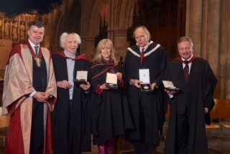

Wedding

Please include in your prayers Fergal Donoghue and Rebecca Cokell who will get married in our church on Saturday 7th April at 4pm, as they prepare for this very important transition of their lives.

David’s Sabbatical Leave – 9th April to 8th July 2018

Last month we announced David’s 3 months Sabbatical Leave from Monday 9th April to Sunday 8th July. During this leave, he plans to explore City of London and Livery links around the world. He will also take the opportunity to visit Livery organisations in Australia, New Zealand and North America. He has created a blog so that he can update us on his travels around the globe.

All regular and booked services during this period will continue. Appropriate cover had been made.

60th Anniversary Appeal and Events

We launched last year our 60th Anniversary Appeal to raise funds (around £25,000) for three new sets of glass doors by July 2018. As of 26th March, we have raised £15,717.63. Thank you very much for those who have supported us in this appeal, most especially to the livery company who donated £60 per each of their active members and the Friends of the City Churches. For those who wish to support us more, please visit our 60th Anniversary Appeal webpage.

The next two events are:

Tuesday 24th April 1pm – “The Essential Magic of the Piano Concerto” - Come and enjoy international piano recitalist and soloist Tessa Uys gives her renowned interpretations on the St. Lawrence Jewry Steinway (formerly owned by Sir Thomas Beecham) - not with her accustomed partner of a full orchestra, but with orchestral accompaniment arranged and played on the celebrated Klais organ by our very own Catherine Ennis.
This is a free event but a suggested donation of £10 will be highly appreciated.

Wednesday 23rd May all day event - Wren Watching (Talking and Walking…) - Come and join City Guides and Lecturers Alexandra Epps and Jill Finch Wren Watching. The morning session will look in depth at the history and stained glass of St Lawrence Jewry. The afternoon session will be a walk from Guildhall Yard to other Wren Churches, discussing Wren, stained glass, the other City churches and their history.
Ticket for each session is £15 but a joint session is only £25. Numbers are limited so book early. Please contact Katrina for tickets or more details.

Online shopping fundraising

All abroad for big donations. Collect FREE donation for St Lawrence Jewry when you book your holiday through easyfundraising. It is easy to do. Just follow these 3 simple steps:

- Go to www.easyfundraising.org.uk/causes/stlawrencejewry/ If you have QR reader on your mobile phone or tablet, just scan this QR code.

- Register yourself by giving your first name, last name, email address and create a password. If you’re a UK taxpayer, you can help us claim 25% more, without any cost from you, by adding Gift Aid to your donation.
- Choose from among +2,000 retailers that you want to shop. Every time you check out, the retailer(s) will donate certain percentage of your total payment to St Lawrence Jewry.

Please don’t forget that we also collect used stamps to raise fund for our church. Please drop them off to the church office and we will do the rest.

General Data Protection Regulation (GDPR)

The new General Data Protection Regulation (GDPR) will take effect in the UK from 25 May 2018. It replaces the existing law on data protection (the Data Protection Act 1998) and gives individuals more rights and protection regarding how their personal data is used by organisations.

Just like any other organisation, parishes and churches, including St Lawrence Jewry, must comply with the requirements of the GDPR. Part of the compliance is for us to ask all the people in our mailing list/electoral roll/Friends of St Lawrence Jewry to fill up a consent form. Last month, we sent you a consent form to complete and return to us. You only need to send us one consent form for the church, whether for the general mailing list or for the Electoral Roll or the Friends of St Lawrence Jewry, etc. Thank you for those who already returned their completed consent form to us. For those who has not done so, we would appreciate it if you can send it back on or before 30th April 2018.

If you have queries about this form, then please contact Arnel Sullano. For more information about our Privacy Notice, please visit our website http://stlawrencejewry.org.uk/privacy-notice/ .

Advance Notices

3rd May - Guild of Freemen Annual Service 6:00pm
20th May - Christian Aid Circle the City event 11am-5pm
23rd May – Wren Watching (walking and Talking) All Day event
23rd May – City, University of London End of Year Recital 6:00pm
24th May – Lloyds Banking Group Annual Service 5:30pm

God bless you all.

David Parrott
vicar@stlawrencejewry.org.uk

If you receive this newsletter but would not wish to stay on our list please let us know straight away and we will remove you.

Katrina Bradley
katrina@stlawrencejewry.org.uk

Arnel Sullano
arnel@stlawrencejewry.org.uk

