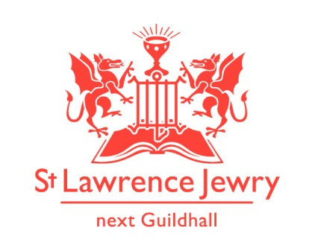
St Lawrence Jewry November 2014 Newsletter
St Lawrence Jewry is the church on Guildhall Yard, dedicated to bringing
the light of Christ to the City of London.

Dear Friends,

“Rejoice always, pray continually, give thanks in all circumstances; for this is God’s will for you in Christ Jesus. “ 1 Thessalonians 5:18

We have lots of things to thank God for:

Thanksgiving No. 1 - Livery Companies Church Services

The livery companies are still continuing their traditions of having their annual church services here. This year, two of our livery companies (WC Constructors and Chartered Architects) actually had their Master’s installation ceremonies incorporated with their church services. Doing so added a spiritual context on the ceremony.

Thanksgiving No. 2 - Music

Music in the church can be classified as world class. Thanks to the collective efforts of Catherine Ennis, our Music Director and Organist and is the current President of the Royal College of Organist; our group of volunteers who helped us in our lunchtime recitals and concerts; our choir who are all professional singers who give the added WOW factor to every service we have in the church and leave the attendees in awe upon hearing their wonderful voices; and the concert organisers who have chosen our church as their concert venue. This November we have the following concerts booked:
German Choir London Concert - Thursday 13th November at 5pm
City of London Boys School Concert - Thursday 20th November at 1pm
Chinese Welfare Trust “A Night of Music” Concert - Tuesday 25th November at 6:45pm

To get the November programmes for our lunchtime recitals, please visit our Piano and Organ webpages or get a printed copy in the church vestibule.

Thanksgiving No. 3 - Lord Mayor’s Installation Day Service

On Friday 7th November at 6pm, we will all gather in the church to give thanks to God for the installation of Alderman Allan Yarrow as the 687th Lord Mayor of the City of London. Everybody are welcome.

Thanksgiving No. 4 - Weddings

We thank God for the having 16 weddings this year. We have two weddings this November:
1st November - Matthew Barker and Hannah Cheston - 4:30pm
15th November - Anthony Doolittle and Emma Knight - 2:30pm

Thanksgiving No. 5 - Memorial Service

We are fortunate to host several Memorial Services to celebrate the lives of some great people who contributed a lot to the City of London. This month, we will celebrate the life of Sir Lawrence Verney on Thursday 6th November at 3pm.

Thanksgiving No. 6 - Friends of St Lawrence Jewry

The Friends of St Lawrence Jewry are continuously growing. We would like to welcome The Worshipful Company of Distillers as our Corporate Member. If you are interested to join our Friends, then please contact Katrina for further details.

Thanksgiving No. 7 - Fundraising activities

We thank Arnel Sullano, our Administrator and Verger, and his supporters, for raising a total of £869 (gift aid not included) in the Ride+Stride event this year. Half of this money will go to our church and half to the Heritage of London Trust. A special thank you goes to Willmott Dixon Interior for donating £500 towards it.

Please help us raise more free funds when you shop online by registering at www.easyfundraising.org.uk How does it work? Please visit the “How do free donations work” leaflet found in our Support Us webpage. So far, we have raised £165.41 from 10 supporters since we launched it last year in November. Register as one of our supporters and start raising money for us at no cost from you at all.

Do you have used stamps? Instead of binning them, why don’t you send or bring them over to the church. We can raise fund by collecting them.

Thanksgiving No. 8 - Advance Events

Thursday 11th December at 1pm – City of London Corporation Staff and Police Carol Service. Chief Commoner in attendance. Festive refreshment follows. All welcome.

Thursday 11th December at 6:30pm – Canticum “Rush Hour Carols” Concert.

Tuesday 16th December at 1pm - Carols for choir and congregation. Our Guild Vicar will tell us the wonderful story of Christmas with the readings while our choir will lead us in singing the carols.

Thursday 18th December at 5:30pm – Lord Mayor’s Carol Service. Lord Mayor and Lady Mayoress in attendance. Mince pies and wine reception follows. All welcome.

God bless you all.

David Parrott
vicar@stlawrencejewry.org.uk

If you receive this newsletter but do not wish to stay on our list please let us know and we will remove you.

Katrina Bradley
katrina@stlawrencejewry.org.uk

Arnel Sullano
arnel@stlawrencejewry.org.uk

