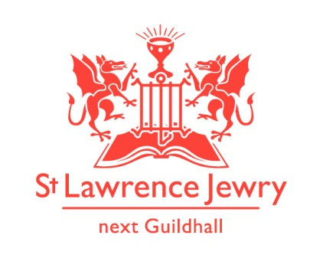
St Lawrence Jewry February 2014 Newsletter
St Lawrence Jewry is the church on Guildhall Yard, dedicated to bringing
the light of Christ to the City of London.

Dear Friends,

“In the same way, let your light shine before others, that they may see your good deeds and glorify your Father in heaven.”
(Matthew 5:16)

Last month was relatively quiet here at the church. Although February has fewer days, we have more activities compared to last month.

Candlemas Service

We started the month with the Candlemas Service last Monday 3rd February 2014 organised by Worshipful Companies of Tallows and Wax Chandlers. It was a wonderful occasion celebrating the fact that Christ came as Light to the World.

Waitangi Day Service

The New Zealand Society UK once again held their Waitangi Day Service in the church last Thursday 6th February. Waitangi Day is a public holiday in New Zealand held each year on 6 February to celebrate the signing of the Treaty of Waitangi, New Zealand's founding document, on that date in 1840. Everyone once again enjoyed this event followed by the tradition hospitality at Girdlers Hall.

Music

Our lunchtime recitals are still growing stronger than ever. The Royal College of Organists’ 150 for 150 Recital Challenge, 150 recitals to celebrate its 150th anniversary, kicked off their London concerts in our church last 11th February. There will be other concerts on the ‘150’ series later in the year.

Monday 17th February is the James Common Memorial Concert, in Memory of James Common who organised our Monday Piano Recitals and August Festivals for more than 15 years until his death in November 2012. The collections made on this Memorial Concert will go towards the piano maintenance and the recital series. Our very own, Catherine Ennis will play the organ with Tessa Uys in the piano. They are playing together two amazing pieces; one by Haydn and one by Schubert. I have enjoyed listening to them rehearse. Even if you are not a regular Monday recital attender this will be one worth coming to!

You can also check out our recital programmes in our website. Please visit our Piano and/or Organ webpages for the complete listing. We have hyperlinked the names of our recitalists with their brief curriculum vitae. To know more about them, just click their names in our programmes list.

Upcoming concerts:

19th Feb - City of London Festival Free Winter Concert Edoardo Catemario (guitar) - 1:05pm
27th Feb - National Opera Studio’s Susan Bullocks Concert 7:30pm – tickets £30

Services each week

Our weekly services continue as usual. Holy Communion at 8.30am on Wednesday and 1.15pm on Friday. Morning Prayer at 8.30am on Monday, Tuesday, Thursday and Friday.

Wedding

We have one wedding this month – Greg Stevens and Emma Young – 15th Feb at 3pm.

Support Us webpage

We created a webpage in our website to inform people how they can help St Lawrence Jewry in fulfilling its missions of bringing the light of Christ to the City of London. Please do visit our Support Us page and get involved.

Since we launched our easyfundraising.org.uk page last November 2013, we already generated £45.39 for the church. If you are buying anything online or are planning to buy something in the future, please register in easyfundraising.org.uk and choose St Lawrence Jewry as the charity you want the retailers to donate to. Examples of the +2,000 retailers included are Tesco & other supermarkets, Amazon, The Trainline and many others. It is really easy once the toolbar has been set up. It will not slow your shopping down. It will simply mean the church gets a donation in the process.

Advance Notice

5th Mar - English Chamber Choir Media Vita Concert 7:30pm - tickets £15 (£10 concessions)
6th Mar - Spital Sermon by the Bishop of Coventry 12noon. Lord Mayor in attendance
20th Mar - Esterhazy Singers Oriana to Serenissima 7:30pm – tickets £15 (£12 in advance)

5th March is Ash Wednesday, the start of Lent. The Bank Churches is holding a course for Lent 2014, exploring and meditating on the Lord’s Prayer. This will be held every Wednesday starting 12th March until 9th April in the Crypt Chapel, St Mary-le-Bow Church, Cheapside EC2. All are welcome.

God bless you all.

David Parrott
vicar@stlawrencejewry.org.uk

If you receive this newsletter but would not wish to stay on our list please let us know straight away and we will remove you.

Katrina Bradley
katrina@stlawrencejewry.org.uk

Arnel Sullano
arnel@stlawrencejewry.org.uk

