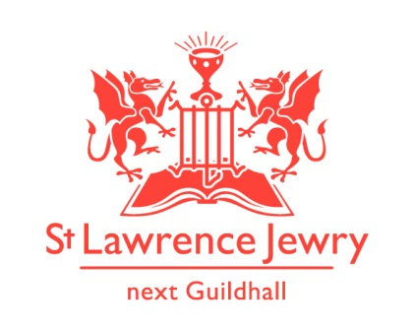
St Lawrence Jewry March 2014 Newsletter
St Lawrence Jewry is the church on Guildhall Yard, dedicated to bringing
the light of Christ to the City of London.

Dear Friends,

“The time has come,” he said. “The kingdom of God has come near. Repent and believe the good news!” (Mark 1:16 NIV)

This month is the beginning of the Lent; a season of fasting and reflection for 40 days before we celebrate Easter. It’s a time when we stop and reflect on how we live our Christian lives. To help us in this reflection, the Bank Churches is holding a course for Lent 2014, exploring and meditating on the Lord’s Prayer. This is held every Wednesday starting 12th March until 9th April in the Crypt Chapel, St Mary-le-Bow Church, Cheapside EC2. All are welcome.

Benefices Evensong

We started our month with the Benefices Evensong on Monday 3rd March at 6pm. This is our chance to support and encourage all the churches whose Vicars are appointed by the Corporation. The Corporation then hosts a dinner afterwards. It was a good evening.

Spital Sermon

On Thursday 6th March at 12 noon we had the Spital Sermon, an ancient tradition with all the usual City pomp. Preaching this year was the Rt Revd Dr Christopher Cocksworth, Bishop of Coventry.

Freemen School Services

Each year Freeman’s School, one of the schools sponsored by the City of London Corporation and now based in Ashstead Park in Surrey, come for a City visit. It took place this year on Wednesday 12th March. There was a service in the morning for the junior school (350 pupils aged 3 to 11) with seniors worshipping in the afternoon (550 pupils aged 11 to 18). There were around 950 students, school’s governors, staff and guardians in attendance this year.

Music

We continue our Sixth Form Series Organ Recital this month. We have a very good line up of students playing in this year series. For more details please visit our Organ webpage. And for our Piano recitals, please visit our Piano webpage

We also have 2 special concerts this month:

5th Mar - English Chamber Choir Media Vita Concert
20th Mar - Esterhazy Singers Oriana to Serenissima 7:30pm – tickets £15 (£12 in advance)

Services each week

Our weekly services continue as usual. Holy Communion at 8.30am on Wednesday and 1.15pm on Friday. Morning Prayer at 8.30am on Monday, Tuesday, Thursday and Friday.

St Lawrence Jewry Pitkin Guide Book Launch

At last! The St Lawrence Jewry Pitkin Guide Book is now published. A book launch is scheduled on Monday 24th March 2014 at 5:30pm in the church itself. This 28-colourful-pages book is packed with historical information about our church and cost only £7. Light refreshment will be served after the launch. This is a free event but we request those who wish to attend to contact Katrina. If you can’t come please drop in and buy a copy, or if you want one posted out (for £10 including postage) please let Katrina know.

Annual Meeting

The Annual Church Meetings take place on Monday 7th April at 6pm at the church. This is an opportunity for all members of our electoral roll to attend and to review the work of the past year and ask questions about the future. The meeting will be followed by refreshments. All are welcome to come along.

Support Us webpage

We created a webpage in our website to inform people how they can help St Lawrence Jewry in fulfilling its missions of bringing the light of Christ to the City of London. Please do visit our Support Us page and get involved.

Since we launched our easyfundraising.org.uk page last November 2013, we already generated £58.81 for the church. If you are buying anything online or are planning to buy something in the future, please register in easyfundraising.org.uk and choose St Lawrence Jewry as the charity you want the retailers to donate to. Examples of the +2,000 retailers included are Tesco & other supermarkets, Amazon, The Trainline and many others. It is really easy once the toolbar has been set up. It will not slow your shopping down. It will simply mean the church gets a donation in the process.

Advance Notice

1st May - 11:45am - Court of Common Council Service. Our next Lord Mayor and civic service.
1st May - 6:00pm – Guild of Freemen Service
22nd May - 5:30pm – Lloyds Banking Group Service

Also, here is another great St Lawrence Jewry event which no one will want to miss.

Historical Notes
St Lawrence Jewry in words and music
28th May 2014 at 6.00pm

An evening of music and history themed around the windows of St Lawrence Jewry. Catherine Ennis will play a piece of music for each era in the church’s history as David Parrott draws out the time line over the centuries. Ticket prices will be in the next newsletter for this event, but it will be a rare and splendid opportunity to link the history of this wonderful church with the music of the centuries. We hope for a big turnout for this one, so save the date now and book as soon as you see the next newsletter.

God bless you all.

David Parrott
vicar@stlawrencejewry.org.uk

If you receive this newsletter but would not wish to stay on our list please let us know straight away and we will remove you.

Katrina Bradley
katrina@stlawrencejewry.org.uk

Arnel Sullano
arnel@stlawrencejewry.org.uk

