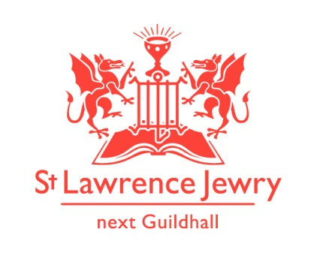
St Lawrence Jewry June 2014 Newsletter
St Lawrence Jewry is the church on Guildhall Yard, dedicated to bringing
the light of Christ to the City of London.

Dear Friends,

” While he was blessing them, he left them and was taken up into heaven. Then they worshiped him and returned to Jerusalem with great joy. And they stayed continually at the temple, praising God.” (Luke 24:51-53 NIV)

Point of reflection during this month. When did you ever experience great joy in your life?

It was yet another busy month of May in the church. We had 1 wedding blessing, 2 baptisms, 2 fundraising activities, 3 special services and 4 weddings, on top of our regular Monday piano recitals and the John Hill Memorial Organ Series which will end on the first week of June and our regular weekday services. Again, we would like to thank everyone involved and who participated in all our events last month. Special thanks to the Friends of City Churches for granting us the money to purchase our big projection screen. It had its first use during the Historical Soundings event on 28th May.

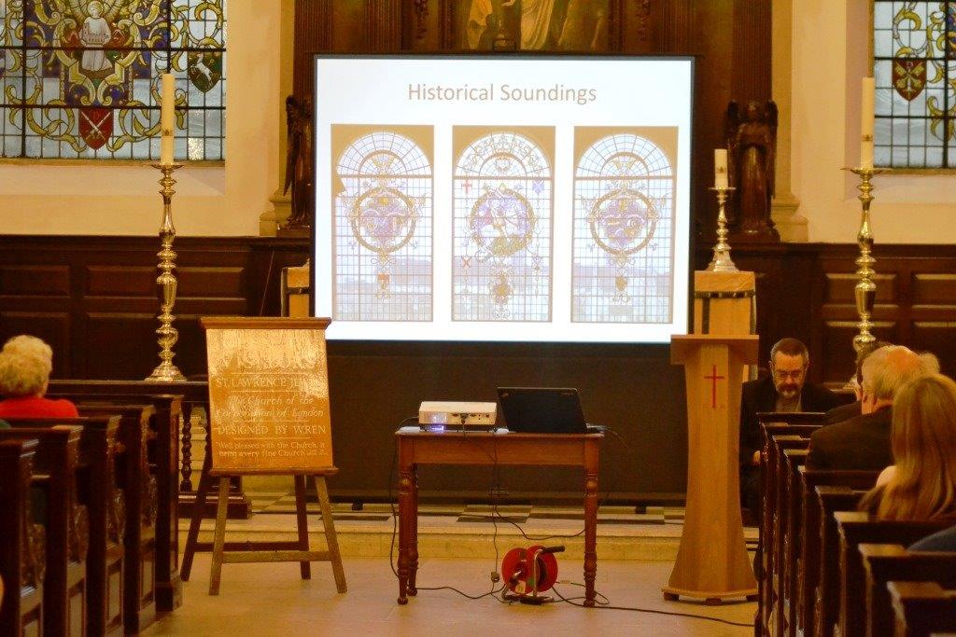
The new screen used during the Historical Soundings event

David is also becoming quite a celebrity now in the City. He was interviewed by the Audio Boo, an initiative of the City of London Corporation PR Department, talking about St Lawrence Jewry and how it plays an important role in the City as the official church of the City of London Corporation and of the Lord Mayor. Please visit our website homepage to hear David’s voice.

Music

Our lunchtime recitals are attracting new audiences as ever. Clelia Iruzun will kick off the Monday Piano recital on 2nd June and Tessa Uys will give us the rest of the Mondays for the whole month of June. Visit our Piano webpage for this month’s programmes.

Tuesday 3rd June will close the 9th Annual John Hill Memorial Organ Recitals with Benjamin Sheen, one of the UK’s brightest young organists, now making big sounds in the US. Catherine Ennis will play two recitals this month followed by Annie Lydford, our guest organist for June. To know more, please visit our Organ webpage.

Services each week

Our weekly services continue as usual. Holy Communion at 8.30am on Wednesday and 1.15pm on Friday. Morning Prayer at 8.30am on Monday, Tuesday, Thursday and Friday.

360 degrees panoramic imagery of St Lawrence Jewry

You can now view a 360 degrees panoramic imagery of St Lawrence Jewry in our website’s homepage, courtesy of Nikhilesh Haval’s unique photographic techniques. You can view the church interiors virtually, as if you are standing right in the middle of the church. Click homepage to experience it.

Tower Chapel

As I write, the redecoration of the Tower Chapel is still in progress but it is now open for public use. Painting has been done; the new candle stand given us by the Worshipful Company of Blacksmith and was made by Steve Millar, a working blacksmith from Essex, is now being used. We are now just awaiting for the delivery of the new carpet; the installations of the Royal Marines’ plaques and the new frontal. We are confident that all of these things will be in place before we’ll have the Rededication of the Tower Chapel in to the Royal Marine Chapel as part of our Annual Service on Tuesday 8th July at 6pm. We are expecting the Lord Mayor, the Sheriffs, some guests from the City of London Corporation and the Royal Marines, the Blacksmith Company, and all those people involved with the redecoration of the chapel. Everyone is welcome to attend.

Memorial Service

We are sorry to hear about the passing of Geoffrey Heywood, a member of the Worshipful Company of Actuaries. His Memorial Service is pencilled in to our church diary as Monday 30th June. We will give more accurate info once we’ve heard from the family and will post it in our website.

Support Us webpage

We created a webpage in our website to inform people how they can help St Lawrence Jewry in fulfilling its missions of bringing the light of Christ to the City of London. Please do visit our Support Us page and get involved.

Since we launched our easyfundraising.org.uk page last November 2013, we already generated £117.65 for the church with 8 supporters. If you are buying anything online, including holidays, or are planning to buy something in the future, please register in easyfundraising.org.uk and choose St Lawrence Jewry as the charity you want the retailers to donate to. Examples of the +2,000 retailers included are Tesco & other supermarkets, Amazon, The Trainline and many others. It is really easy once the toolbar has been set up. It will not slow your shopping down. It will simply mean the church gets a donation in the process.

RIDE + STRIDE 2014, Saturday 20th September

This is a nationwide fundraising event and St Lawrence Jewry is participating again to help raise fund for the church and the preservation of London’s unique historic buildings and monuments. We need volunteers who will act as riders, striders or stewards in this event and get sponsored for it. Please visit our Ride+Stride webpage for more details on how to support us. Our Administrator/Verger, Arnel Sullano, will do the riding and striding for us. To sponsor him, please visit St Lawrence Jewry Church’s fundraising webpage.

Advance Notice

8th July - 6:00pm – St Lawrence Annual Service and Dedication of the Royal Marines Chapel. This is a free event and everyone are welcome. Refreshment will follow after the service.

14th July - 6:00pm - Summer Mosaics Launch for Friends of St Lawrence Jewry.
(Please contact Katrina for more details)

God bless you all.

David Parrott
vicar@stlawrencejewry.org.uk

If you receive this newsletter but would not wish to stay on our list please let us know straight away and we will remove you.

Katrina Bradley
katrina@stlawrencejewry.org.uk

Arnel Sullano
arnel@stlawrencejewry.org.uk

