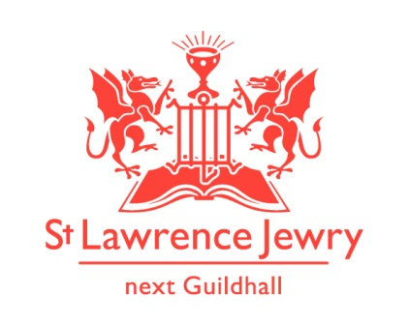
St Lawrence Jewry December 2013 Newsletter
St Lawrence Jewry is the church on Guildhall Yard, dedicated to bringing
the light of Christ to the City of London.

Dear Friends,

“For God so loved the world that he gave his one and only Son, that whoever believes in him shall not perish but have eternal life.” John 3:16

Christmas season is here and you can feel the hustle and bustle everywhere, not only in shops but also in St Lawrence Jewry.

But the spirit of Christmas is not about us being busy with carol services, or shopping, or sending Christmas cards to people. It is the spirit of love, of giving, of believing. We as Christians, celebrate Jesus’ birth at Christmas, the day we receive the greatest gift of all, our dear Saviour, Jesus Christ. This Christmas season, let us remember the other gifts God is continuously giving us through St Lawrence Jewry.

Gift No. 1 – Carol Services

Our church will be filled with carol songs again with 14 carol services in the next few weeks. All services are open to the public (although where an organisation is doing refreshments afterwards these are not usually open to all comers), but the two we particularly invite you to amongst these carol services are:

The City of London Corporation Staff and City Police Carol Service Thursday 19th December 1:10pm

The Lord Mayor’s Carol Service Monday 23rd December 5:30pm.
Refreshments will follow after these two services. Everyone is invited. The Lord Mayor will be at both these services.

Gift No. 2 – Music

Aside from the 14 carol services, we also have 9 concerts/recitals. For programmes of our Monday and Tuesday recitals, please visit our website. Other dates to remember:
3rd December 6:30pm - Meningitis Now Christmas Concert tickets £10
4th December 7:30pm - London Lawyers’ Music Chorus/Chamber Orchestra Concert
Tickets £10
17th December 1pm - SLJ Organ and Choir with Reading Carol Concert – free
19th December 6:30pm- City Chamber Choir Concert – tickets £12/9 concessions

Gift No. 3 - Wedding

Mike Crowe and Isabel Hawes will be married on Saturday 21st December at 1pm. We pray for God’s blessing on them.

Gift No. 4 – Support Us webpage

We just created a webpage in our website to inform people how can they help St Lawrence Jewry in fulfilling its missions of bringing Christ to the City of London. Please do visit our Support Us page and get involved.

Since we launched our easyfundraising.org.uk page last month, we have now 3 supporters who generated £18.70 for the church. If you are buying anything online or are planning to buy something in the future, please register in easyfundraising.org.uk and choose St Lawrence Jewry as the charity you want the retailers to donate to. It is really easy once the toolbar has been set up. It will not slow your shopping down, it will simply mean the church gets a donation in the process.

Gift No. 5 - St Lawrence Jewry Books

What can you give someone who already have most of what he needs? The answer is: give him/her one of St Lawrence Jewry books.

The Rules for the Conduct of Life 2nd Edition - £7.00
The Windows of St Lawrence Jewry - £5.00

Arnel can even wrap them up for you for any donation towards the church. Please contact him if you wish to order them.

More Gifts to come

Plow Monday Service – 6th January at 12:30pm. Lord Mayor and her Consort in attendance. This is the service in which we pray for the staff and work of the City of London Corporation at the beginning of another year.

As one year is about to end, we give our heartfelt gratitude to everyone who have been involved, in one way or another, with St Lawrence Jewry this year. It has been a very busy year for us that brought lots of joy in our hearts. To all the livery companies down to the single individual who have given their supports to us, words are not enough to thank you all.

Church Opening Times

The church will be closed from 24th December 2013 until 1st January 2014. We will open our door again starting 2nd January 2014.

We wish you all a very happy Christmas and a peaceful new year to come.

David Parrott
vicar@stlawrencejewry.org.uk

If you receive this newsletter but do not wish to stay on our list please let us know and we will remove you.

Katrina Bradley
katrina@stlawrencejewry.org.uk

Arnel Sullano
arnel@stlawrencejewry.org.uk

