‘Circle the City’ Sponsored Walk for Christian Aid, 19th May 2013

‘Circle the City’ is a 5¹/₂ mile circular sponsored walk for Christian Aid, visiting some of the historic churches in the ’Square Mile’ – City of London.

My starting point was St. Mary-le-Bow, Cheapside. Having registered, I familiarised myself with the route booklet which was very informative. This included precise details of the directions between each venue, other places of interest, and a map. For each building there was also some historical information, ‘things to find’, and symbols indicating the facilities available at each place e.g. refreshments, accessibility, activities for children.

When everyone had been checked in we gathered in the church for the pre–walk service. 19th May was Pentecost/Whit Sunday and the vicar told us that it was a very appropriate day for a sponsored walk, as in the past particularly in Northern Britain, it was traditional to go on a pilgrimage at this season. Apparently the children were given new white clothes to symbolise the purity of the Holy Spirit – not very practical for a pilgrimage walk! A member of Christian Aid staff then led us in the Lord’s Prayer and highlighted the relevance of the first few lines to the work of Christian Aid and our contribution to it. This was therefore an important and very visible type of witness and ministry.

St. Mary-le-Bow before the pre-walk service

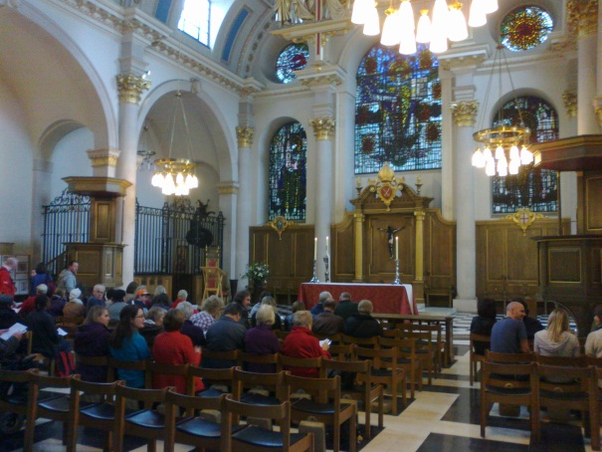

Then we were sent on our way… so armed with a Christian Aid balloon adorning my rucksack and a charity ‘bug’ pinned to my cap, I left St. Mary-le-Bow with my fellow walkers. Turning into Bow Lane we headed south towards the Thames and our first venue, St. James Garlickhythe.

Many of the churches on the route were designed by Sir Christopher Wren following the Great Fire of London when the original churches were destroyed. Many of these were then damaged during the Second World War but have been restored following Wren’s general pattern but with additional features. St. James Garlickhythe is one of these churches but was also damaged in the 1990s when a crane fell through the roof therefore requiring more recent restoration. It retains its high, clear glass windows, a feature of Wren’s work giving it the nickname ‘Wren’s Lantern’. It is now the proud home of the Royal Jubilee Bells which were rung on a barge leading last year’s Thames Diamond Jubilee Pageant. Like many of the city churches St. James has an unusual extra name. In the 17th Century there were so many churches in close proximity that there needed to be a way of distinguishing those with the same saint’s dedication. Often the location was used for this purpose so this particular St. James was near the wharf or ‘hythe’ where exotic goods like garlic were unloaded – hence its ‘surname’.

Our next church had a similarly intriguing name – St. Andrew-by-the-Wardrobe. The Wardrobe was well known in the Middle Ages as the building which stored the king’s ceremonial robes. St. Bride’s, Fleet Street was our next destination and marked the walk’s furthest point west. It is famous for its spire which was said to have inspired the tiered wedding cake. Unfortunately it was not possible to admire this architectural gem as it was hidden behind scaffolding and swathes of plastic sheet! Retracing our steps eastwards we approached Wren’s most famous and awe-inspiring landmark, his magnificent masterpiece – St. Paul’s Cathedral. This was the location of our first Prayer Point. Unlike many of its Wren ‘siblings’, St. Paul’s miraculously survived the Blitz of 1940 undamaged. So here we were asked to pause for a few moments and reflect on all who have lived through, and continue to live in times and places of war and conflict.

Turning north, we passed under Temple Bar, originally the western gateway to the City of London and also designed by Wren. Having been removed and spending a century in a Hertfordshire wood it was rediscovered, restored, and is now an entrance to Paternoster Square. Crossing the square and continuing north, we passed the ruins of Christ Church Greyfriars. In Mediaeval times it was one of the largest churches in the city but after war damage only the spire was restored and the ruins were converted into a garden. A little further north we came to a unique and probably the most poignant place on the walk – Postman’s Park. This tranquil garden is the location of a remarkable monument, a series of commemorative tiles, known as The Memorial to Heroic Self-Sacrifice. Unveiled in 1900, it commemorates selfless acts of courage and bravery by ordinary members of the public who lost their lives saving other people, often complete strangers, from terrible situations including fires, drowning, explosions and transport accidents. Both victims and rescuers represent all ages and classes of society and many locations are familiar to us. One example involved a 19 year old who drowned attempting to rescue a lad from ‘a dangerous entanglement of weed’ in the River Lea. Another man lost his life ‘averting a serious accident to a lady in Hyde Park’ when a pole on her carriage broke and the horses became ‘unmanageable’. However, the description of a young boy’s brave actions shown below needs no further explanation.

Memorial to Heroic Self-Sacrifice

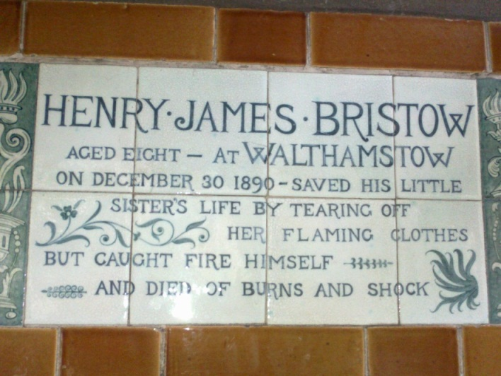
This was our second Prayer Point so here we were asked to remember how ordinary people can do extraordinary things in extreme circumstances, often disregarding their own safety demonstrating the ultimate expression of love.

We then continued to the church at the northernmost point of the route – St. Giles Cripplegate, Barbican. This is one of the few remaining churches of Mediaeval origin which survived the Great Fire, although damaged in WWII. It seems rather out of place, almost on an island juxtaposed between remains of the old Roman wall and the iconic buildings of the Barbican Estate. I know it very well as it is used for special services by the City of London School For Girls where I work.

St. Giles Cripplegate

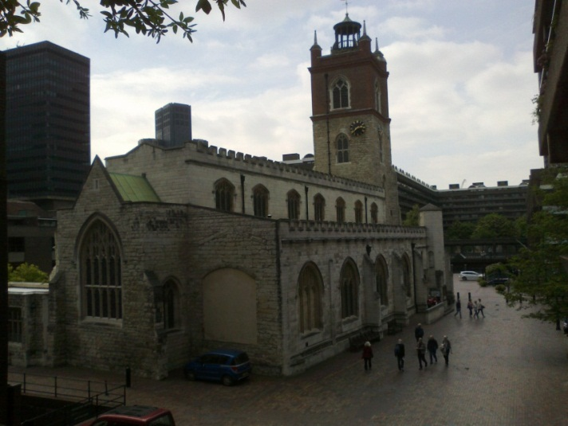

Changing direction, we walked along London Wall passing two churches where only the towers remain (St. Alban, Wood Street and St. Alphage, London Wall) to reach our furthest point east, St. Botolph-without-Bishopsgate and close-by, St. Ethelburga’s. This tiny church was completely restored after it was destroyed by an IRA bomb in 1993. St. Botolph was also damaged at the same time as was our next venue, the one I found most interesting – Bevis Marks Synagogue. Close to the modern landmark known as ‘The Gherkin’, you would be forgiven for thinking this building was another city church. Its exterior shape and beautiful interior with dark oak benches, gallery, high arched clear glass windows and long chandeliers is very similar to Wren’s designs. The simple reason is that when it was built the Jewish community did not want it to stand out from the other buildings and the craftsmen involved in its construction would have also been building the churches. This was the first synagogue to be built (1701) in Britain after the Jews were allowed back here in the 17th Century having been expelled at the end of the 13th. This community were of Spanish/Portuguese origin but the interior and furnishings were based partly on a large synagogue in Amsterdam. It has remained in almost completely original state having suffered only minor damage in the war and IRA bombing.

Bevis Marks Synagogue

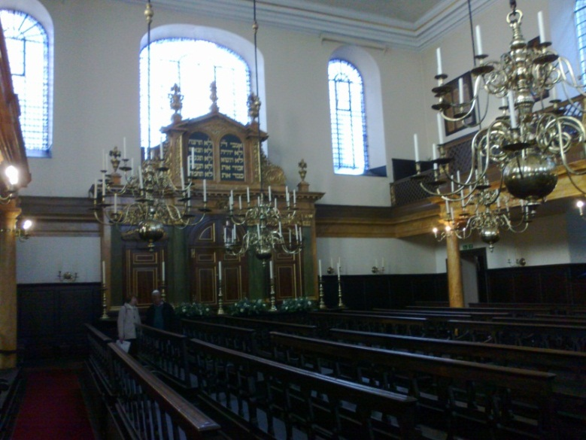

Our route then took us south towards the river again to All Hallows-by-the-Tower. Also known as All Hallows Barking-by-the-Tower, it was founded from Barking Abbey and marks the beginning of Christian history in London. A little further east we reached our third Prayer Point - another ruined church, spire and garden: St. Dunstan-in-the-East. This church was said to have Wren’s strongest spire which still stands as does much of the structure. Entering via the remaining doorway and porch you find yourself in an enclosed garden with central, circular, flat stone water feature and plants climbing the walls. It has a peaceful, enchanting atmosphere and here we were asked to remember the relationship between God, His people and creation. It reminded us that out of ruined lives and broken relationships can come beauty and creativity with God’s help.

St. Dunstan-in-the-East

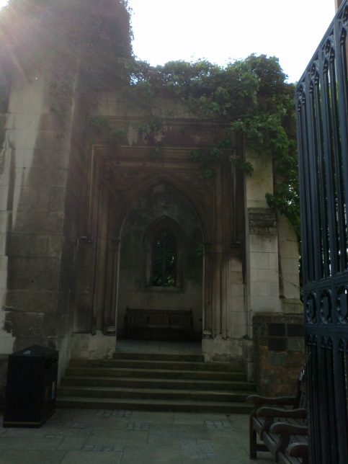
Turning north we began the final section towards the heart of the city and two churches close to Bank. St. Mary Woolnoth was designed by another well - known architect, Nicholas Hawksmoor. It survived having Bank tube station built beneath it and one of its rectors was the author of ‘Amazing Grace’ – John Newton. Nearby St. Margaret Lothbury is a good example of a church whose current congregation is mainly city workers and do not live in the area. As city residents decreased the need for so many churches also decreased, churches were closed and parishes amalgamated. Hence St. Margaret’s parish now encompasses seven others!

The end of our walk was now getting closer as we turned west to arrive at St. Lawrence Jewry-next-Guildhall. As its name suggests, this church stands across the yard from the imposing Guildhall which is the administrative centre for the City of London Corporation. It is the church for the Lord Mayor of London and CoL employees and is therefore my ‘work’ church. It is a Guild church rather than a parish church and has a fascinating history being linked with a number of Livery Companies, Armed Forces and other societies. Its most striking features are the windows installed during its restoration after war damage. These beautiful stained glass images depicting various saints, coats of arms and The Ascension, were designed to have a clear glass border to allow the maximum amount of light to enter the building. The most unusual bears an image of Wren himself with his craftsmen and some of his other churches. The most recently installed window was given by the Ward of Cheap to mark their 150th Anniversary this year and was dedicated at a special service in April.

The Wren Window, St. Lawrence Jewry

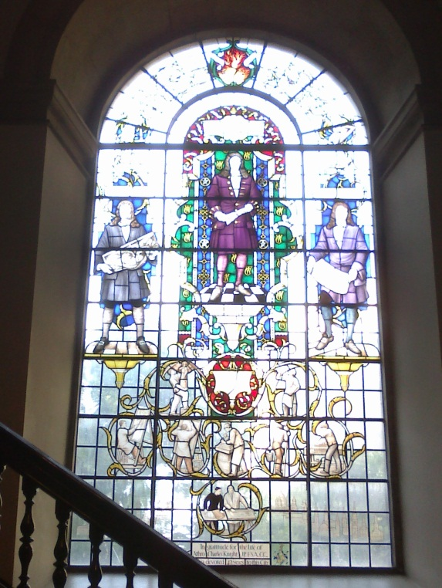

It was then just a short walk back to our starting point, St. Mary-le-Bow. This church is home to the famous ‘Bow Bells‘ beloved of all true Cockneys, which according to legend called Dick Whittington back to the city to become the first Lord Mayor of London.
And so after about four hours I had completed my walk: 11 churches, 2 ruins, 1 garden, 1 synagogue and 1 cathedral! I thoroughly enjoyed my afternoon discovering some of the city churches and other buildings and hope to take part again next year. Of course I cannot end without thanking everyone for their generous support and to friends and family who canvassed for sponsors. I raised a Grand Total of £452.00 excluding Gift Aid! AMAZING!!!

Jenny Houghton

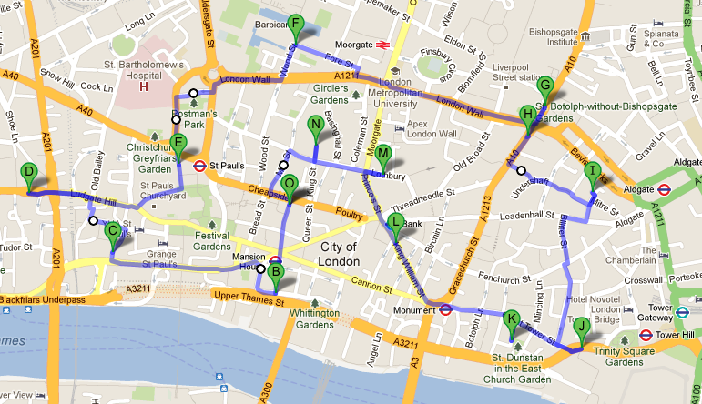

Start/End: O St. Mary-le-Bow H St. Ethelburga’s
B St. James Garlickhythe I Bevis Marks Synagogue
C St. Andrew-by-the-Wardrobe J All Hallows-by-the-Tower
D St. Bride’s, Fleet Street K St. Dunstan-in-the-East Garden
E Christ Church Greyfriars Garden L St. Mary Woolnoth
F St. Giles, Cripplegate M St. Margaret Lothbury
G St. Botolph-without-Bishopsgate N St. Lawrence Jewry-next-Guildhall

