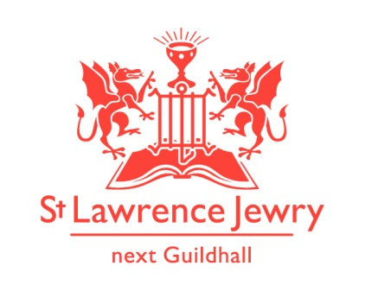
St Lawrence Jewry March 2013 Newsletter
St Lawrence Jewry is the church on Guildhall Yard, dedicated to bringing
the light of Christ to the City of London.

Dear Friends,

Repent! For lent is here. It’s a season where we Christians prepare through prayers, penance, repentance, almsgiving and self-denial. Here in St Lawrence, we out bit of self-denial, by working harder in keeping our church more active each day.

March events

March will be another busy month. We thought you may like to know about a few of the events taking place.

Each year Freemen’s School, one of the schools sponsored by the City of London Corporation and now based in Ashstead Park in Surrey, come for a City visit. This will take place on 6th March. There will be a service in the morning for the junior school with seniors worshipping in the afternoon – about 400 pupils at each. It is one of our great days here to have so many youngsters in church.

The annual Spital Sermon will be at 12noon on 7th preached by a Bishop of the Church of England to the Court of Aldermen and others, is an ancient tradition with all the usual City pomp. It is open to the public.

Finally, the United Guilds Service takes place on 15th March at St Paul’s Cathedral. This is one of the great City occasions, when the Cathedral is packed with Liveryman of all 108 companies. Again David Parrott will be in attendance to represent St Lawrence Jewry’s links with the Livery movement as well as the nine Liveries to whom he is Chaplain.

Lent 2013

Bank Churches Lent Course, “Being the People of Peace”, is also on-going in St Mary Aldermary every Wednesday, at 7:30pm. There is an art installations, a creative reinterpretation of the Stations of the Cross, and the Lent Course exploring the spiritual season with insights from a book about non-violent communication. For further details, please visit this webpage http://www.moot.uk.net/events/lent-2013/.

Music

Music is continuously drawing crowds in our church. Our Piano and Organ recitals are thriving than ever. For details of programme this month of March, please visit our webpages Piano or Organ.

A special Memorial Concert in James Common memory last 18th February was a huge success. A big appreciation to Tessa Uys (piano), Mikhail Shilyaev (piano) and Catherine Ennis (organ) who played in the said concert in gratis. We were able to raise £675.90, which Ruth kindly agreed to donate to the church for our piano maintenance and tuning works. Thank you Ruth for this generous gesture.

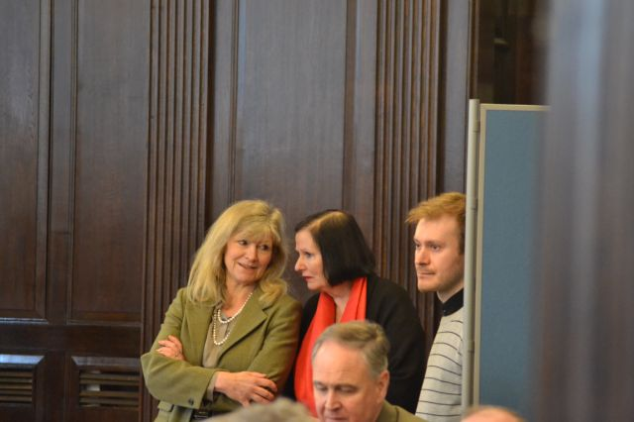

The Sixth Form Organ Series 2013, presenting the top sixth-form organists from around the UK, is now on-going. Programmes are available through the Organ webpage.

We also have 2 special concerts in our church: 7th March - City Chamber Choir Requiem Concert at 7:30pm and 21st March – London Lawyers’ Music Chorus and Chamber Orchestra Concert at 7:30pm. For further details and ticket information, please visit their websites below: http://www.citychamber.org.uk/concerts.htm#date4 http://www.lawyersmusic.org.uk/index.asp?page_ID=12

Services each week

Our weekly services continue as usual. Holy Communion at 8.30am on Wednesday and 1.15pm on Friday. Morning Prayer at 8.30am on Monday, Tuesday, Thursday and Friday.

Advance Notice

15th April 5:45 pm - Ward of Cheap Event – Dedication of the new window, Lord Mayor and his
Sheriffs attending. Refreshments in the church after the service.
1st July 6pm - St Lawrence Jewry Annual Rededication Service, Lord Mayor and Lady
Mayoress attending. Refreshments in the church after the service.

New email addresses

Please take note of our new work email addresses below. Update your system with the new email addresses.

God bless you all.

David Parrott
vicar@stlawrencejewry.org.uk

If you receive this newsletter but would not wish to stay on our list please let us know straight away and we will remove you.

Katrina Bradley
katrina@stlawrencejewry.org.uk

Arnel Sullano
arnel@stlawrencejewry.org.uk

