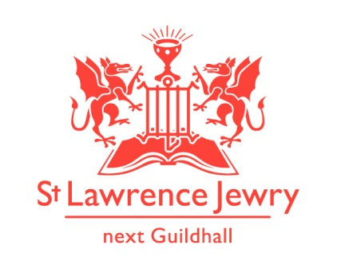
St Lawrence Jewry JULY 2013 Newsletter
St Lawrence Jewry is the church on Guildhall Yard, dedicated to bringing
the light of Christ to the City of London.

Dear Friends,

“Ants are creatures of little strength, yet they store up their food in the summer.” ( Proverbs 30:24 NIV ) Like ants, we are also gathering our little strengths for the continuous coming of events in the church. Luckily, we have supportive members rallying behind us. We really appreciate with all your help.
One of the help that we received was from Bridget Clarke, one of our Guild Church Council members. She has donated a new wedding kneeler for the church. We thank her for her hardwork and generosity. It has already been used twice last month. Two more will be using them this month of July. Love must be in the air these days.
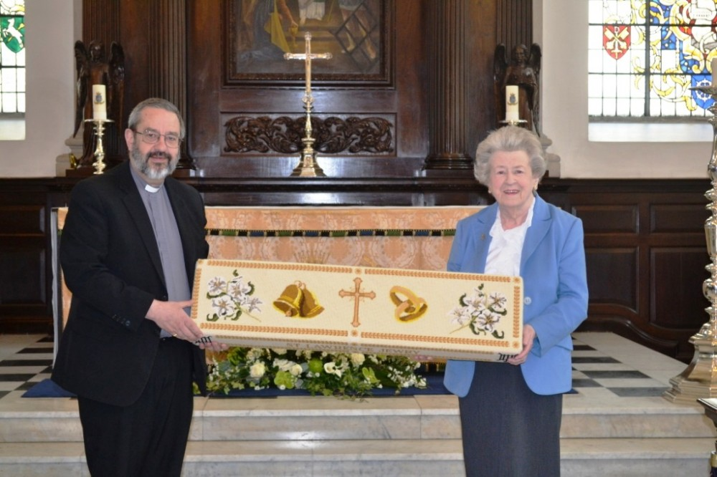

St Lawrence Jewry Annual Rededication Service

We kick of the month of July with our Annual Rededication Service. It has been 66 years since our church had been dedicated after it was destroyed during the Blitz. This year Annual service will be on Monday 1st July 2013 at 6pm. The Lord Mayor, Lady Mayoress and other bigwigs of the City of London Corporation will be in attendance. Refreshment will follow in the Commonwealth chapel. Please join us in this Annual Service and let’s pray together in thanksgiving for all the blessings that our church has been receiving from our patrons and donors

Services each week

Our weekly services continue as usual. Holy Communion at 8.30am on Wednesday and 1.15pm on Friday. Morning Prayer at 8.30am on Monday, Tuesday, Thursday and Friday. We are happy to note that there is a continuous stream of visitors who leave prayer requests in our Tower Chapel and we include all of them during our Morning Prayer. If any of you have prayer request, kindly contact any of our team below through email. Better yet, do come and pray in our Tower Chapel and write your prayer request on the form provided.

Weddings

This month we have 2 weddings:
Copeman – De Mott Saturday 13th July
Preece-Smith - Phillips Saturday 20th July

Music

There will be no recitals on the first week of July, to give way to the Music in the (Guildhall) Yard, organised by the City of London Festival that week. Regular recitals will follow on the second week.

Our Piano Monday recitalists for July are Elena Vorotko, Holly Cullen, Catherine Cheung and Primavera Shima. For details of their programmes, please visit our Piano webpage.

Aside from Catherine, we have 2 visiting organists this month for our organ recitals: Richard Brasier, from Cologne and a Nicholas Danby Scholar, and Konstantin Volostnov from Russia. For the full details of their programmes, please visit our Organ webpage.

Friends of St Lawrence Jewry

Those of you who has not joined us as Friends of St Lawrence Jewry, we encourage you to do so. Not only will you be helping our church to generate income for us to continuously do our mission of being the light to the City of London, but you will also enjoy the company of your fellow Friends in the various events we organise for them.

Exhibits

St Lawrence Jewry is hosting again 2 exhibitions this summer. The Foundry project was initiated in 2008 in conjunction with The Worshipful Company of Founders and artist Irene Gunston. Fifteen students from City of London Academy Southwark worked with medallist Phoebe Stannard to design and cast their own bronze art medal inspired by the 2013 Festival themes. This year the Festival is linking closely with Derry~Londonderry in their year as UK City of Culture, and looking more specifically at the walls that the City of London built around Derry 400 years ago. With walls comes the natural exploration also of conflict and resolution. In addition to this theme, the Festival annually features an environmental strand, this year, quite aptly, ‘trees’ (Derry translates as oak grove). The medals will be displayed in our church from Sunday 23 June – Friday 12 July. Please come and see the fruits of these students' creativity and hardwork.

From 10th July to 22nd September, we are also hosting the Summer Mosaics Exhibition 2013. Our very own Sue Parrott will display some of her works. This event is in cooperation with the Southbank Mosaics. Private view at 6pm on Monday 8th July. Please book in with Katrina.

August Festival

Our August Festival takes place as usual this year with a concert every weekday during the month at 1.00pm. See August Summer Festival of Music for full details. The series this year will celebrate Schubert, arguably one of the six greatest composers of all time and, in the centenary of his birth, Britten, probably the greatest British composer since Purcell.

London Ride+Stride 2013, Saturday 14th September

Ride+Stride is a national event, where people are sponsored to walk or cycle between places of worship. Many places of worship that are not normally open will be welcoming participants on the day, and this is wonderful opportunity to see the wealth of religious buildings across London. The money raised is split, with half going to the place of worship of your choice, and half to the Heritage of London Trust for future repairs to religious buildings in London.

We are seeking volunteers to do this event for St Lawrence Jewry, either as riders/striders or as stewards in the church. Please contact Arnel Sullano for further details.

God bless you all.

David Parrott
vicar@stlawrencejewry.org.uk

If you receive this newsletter but would not wish to stay on our list please let us know straight away and we will remove you.

Katrina Bradley
katrina@stlawrencejewry.org.uk

Arnel Sullano
arnel@stlawrencejewry.org.uk

