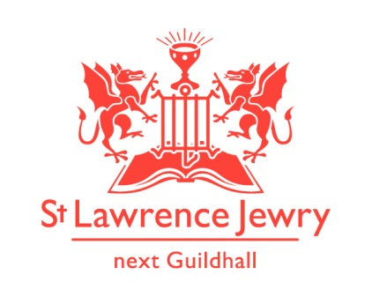
St Lawrence Jewry SEPTEMBER 2013 Newsletter
St Lawrence Jewry is the church on Guildhall Yard, dedicated to bringing
the light of Christ to the City of London.

Dear Friends,

“Begin the music, strike the timbrel, play the melodious harp and lyre.” (Psalm 81:2 NIV) Our church has been filled with different kinds of music for the last month, with our daily lunchtime music festival. The theme was Britten and Schubert, and we heard much of their music as well as other pieces. A special thank you to Graham Allum and his lovely wife, Sarah Walker, who organised the artists in this year’s festival and to Katrina Bradley, who oversaw the whole process. We would also like to thank our sponsors, Lilian and Henry Stephenson and Willmott Dixon, and our volunteers, Jenny Houghton and Ian Lightfoot for helping out. We also acknowledge the presence of the Friends of City Churches throughout the festival.

Next year is the 450th anniversary of the birth of Shakespeare. To be or not to be? That is the question as to whether we shall have a theme. Watch this space.

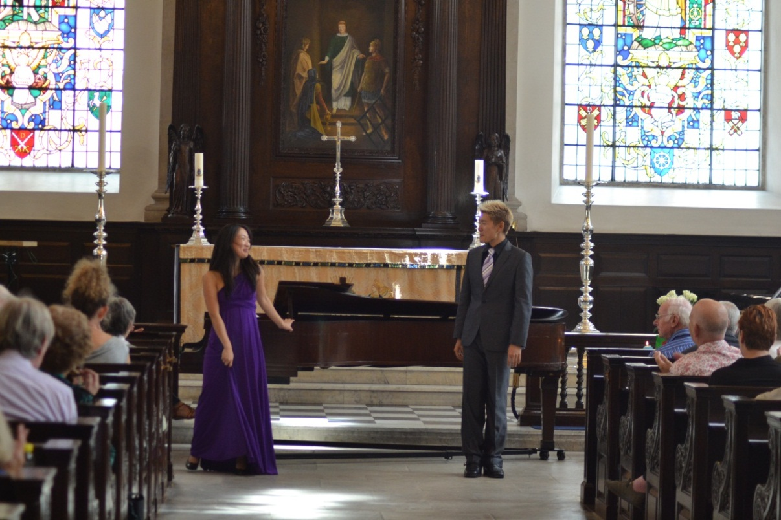

Music

Our weekly Monday Piano and Tuesday Organ recitals resume this month after a month’s break to give way to the August Music Festival. Programmes are available in the church or visit our webpages Piano and Organ.

Friends of St Lawrence Jewry

Those of you who have not joined us as Friends of St Lawrence Jewry, are encouraged to do so. Not only will you be helping our church to generate income for us to continue our mission of being the light to the City of London, but you will also enjoy the company of your fellow Friends in the various events we organise for them. Please contact Katrina for further details.

Summer Mosaics Exhibition 2013

The Summer Mosaics Exhibition 2013 is continuing until Sunday 22nd September 2013. The mosaics on display in our Commonwealth Chapel are works done by the Southbank Mosaics, including some by young people referred to the project by the London Probation Trust and Lambeth Youth Offending Team. This is an exciting artistic community project which we are pleased to support. The mosaics in the Tower Chapel are religious in theme. They are works by Sue Parrott.

If you have not seen the mosaics, please do come and visit us. You might even be tempted to buy some of the works that are still on sale.

London Ride+Stride 2013, Saturday 14th September

Ride+Stride is a national event, where people are sponsored to walk or cycle between places of worship. Many places of worship that are not normally open will be welcoming participants on the day, and a wonderful opportunity to see the wealth of religious buildings across London. The money raised is divided, with half going to the place of worship of your choice, and half to the Heritage of London Trust for future repairs to religious buildings in London.

We are seeking volunteers to participate in this event for St Lawrence Jewry, either as riders/striders or as stewards in the church. Please contact Arnel Sullano for further details.

Anya & Joseph Sutton, married in our church last July 2013, are taking part in this event on behalf of St Lawrence Jewry. To sponsor them, please go to their JustGiving webpage http://uk.virginmoneygiving.com/team/JosephandAnyaforStLawrence or you can drop into the church and speak to Arnel Sullano.

Open City Weekend – 21st – 22nd September 2013

Saturday 21st – Sunday 22nd September - Open City Weekend. As usual we will be open all this weekend. The mosaics exhibition continues, there will be guides available and we usually welcome 3000 people over the weekend. There will be a mosaics demonstration by David Tootill, Artistic Director of Southbank Mosaics, from 10am to 1pm on Sunday 22nd September.

Weddings/Blessing

We have two weddings and a 25th Wedding Anniversary Blessing this month.

Simon Henderson & Dawn Dillaway - 6th September 3:00pm
Christopher Goulson & Amelia Hellyer - 14th September 1:00pm
Stephen & Tracy Wait Thanksgiving for 25 yrs of Marriage - 28th September 1:30pm

Lord Mayor’s Election Day Service

The Lord Mayor’s Election Day service takes place on the 30th September at 10:45am. This is one of the great Civic events of the year, where all Masters of Livery companies & Aldermen with their respective beadles process from the Great Hall of the Guildhall to the church to seek spiritual guidance from God before electing a new Lord Mayor. It takes a lot of organising. Again please pray for this key event in the life of our church.
BBC Radio 4 Interview

We now have a celebrity in the church. David was interviewed by Radio 4 for its “The Bishop & the Bankers” series and was aired on Monday 29th July at 8pm. For those who missed the chance to listen to it, here is the link http://www.bbc.co.uk/programmes/b037h1yg.

Advance Notice

7th November at 7pm - “The Magic Flute” – first full opera being presented in our church. Mozart's fantastic opera blends fairy-tale adventure and playful comedy to tell a tale of magic, power and love with music as enchanting and spectacular as the plot is mysterious. Sung in English with chamber orchestra; performed by Opera Project; and organised by The Worshipful Company of Girdlers. Tickets are £50 in aid of our church. For ticket enquiries, please contact Robin.neill@stjohnschambers.co.uk or PReeve@albion-ventures.co.uk.

Enjoy the warm weather while it lasts. God bless you all.

David Parrott
vicar@stlawrencejewry.org.uk

If you receive this newsletter but do not wish to stay on our list please let us know and we will remove you.

Katrina Bradley
katrina@stlawrencejewry.org.uk

Arnel Sullano
arnel@stlawrencejewry.org.uk

